Remote Repository Creation

Firstly You breed to loigin to your profile and create repository by clicking on New button on repository page



After clicking on that New Button  Following page will open

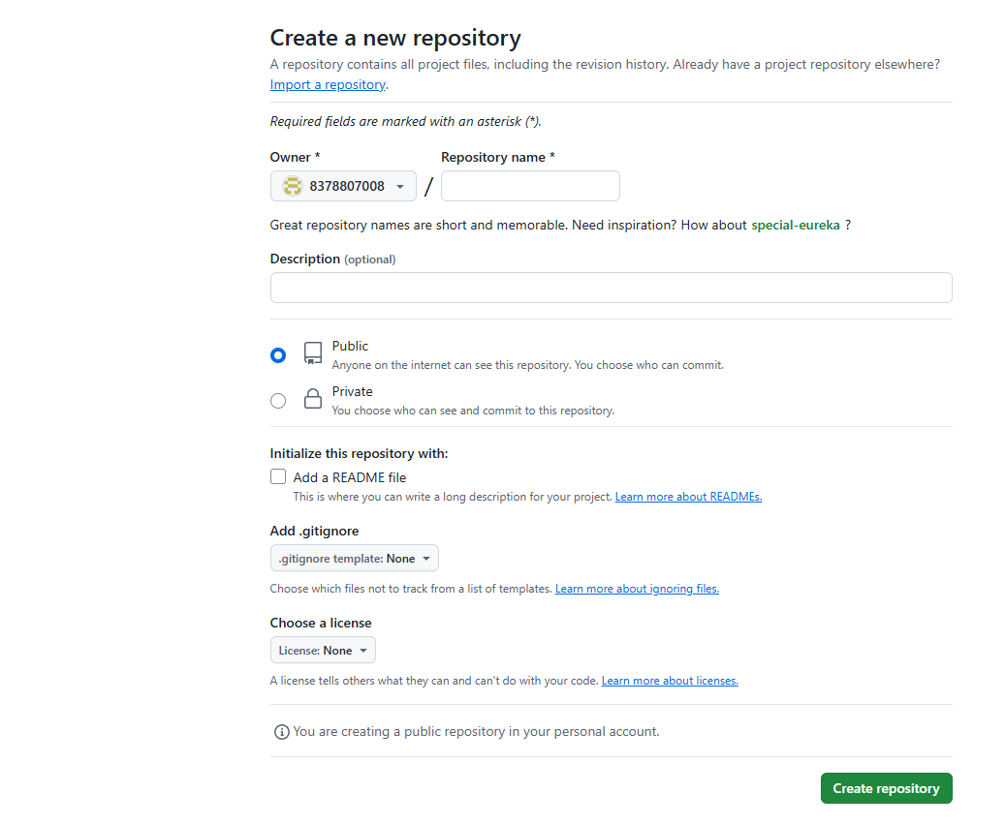

Add repo name and select public /private option and click on create repository to join these repository to your local you need to perform Following steps

1. To create repository  you need to create project directory. And then enter to the directory.

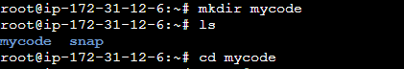

2. Then initialize the git in it

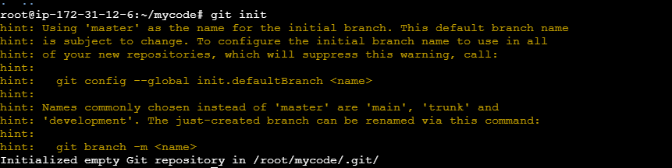

3. Create your sourcecode file

https://lh7-rt.googleusercontent.com/docsz/AD_4nXfeLqJUKH2kVlqrZ-qiScW3N-KY_RANa-4ujqbz6p-yb5jbj5oQxNDae_ak_owxcBph3b1zuUOdprmfLNVueN47etkFxYA9-RS0Ofl8MRR3aAj2WrFO8GLn7R10CJ9Y3zyg7t9p?key=or8XTluCLmyXyg8SoRvMNg



4. And then  push that file in staging area with help of git add .

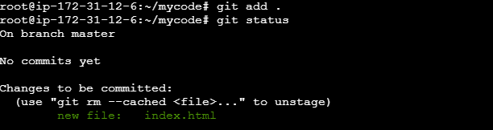

5. Commit the changes by git commit -m "V1"

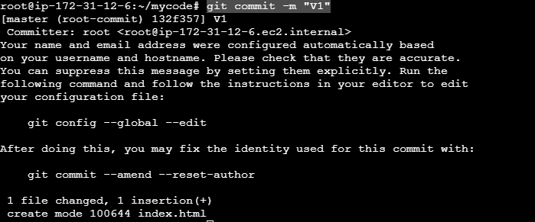

6. Now Create  a branch of it by using git branch -M Dev

https://lh7-rt.googleusercontent.com/docsz/AD_4nXf9506xM9Q5Vqw7uqzzGsDTV3zD7IEbB2pXLHZx3Bl3AlWAMeB171emPVJ8WuPV5xJIe5FWkZhjU4R5xEGFfZU71UyNc0CEztO_XroCgwWVr5pVbIgWPcymAZbVPnaO62L79Hrg?key=or8XTluCLmyXyg8SoRvMNg

7. Now you need to connect these repository to remote repository by using  git remote add origin https://github.com/8378807008/Test.git

https://lh7-rt.googleusercontent.com/docsz/AD_4nXfRGK0lqzyaniinNOVxIuGRgEc5OsRowiW0rHDxP2Ck5FXI_nLblWPNko0D1v8gBCPpdzxbvhfn7_sOF0ai28aZcHYHbHPMnbSlApA_5vWTRyoNdd4hu4sqRtql3hvr2YCjOxWAzg?key=or8XTluCLmyXyg8SoRvMNg

The origin word is use to mask  these url <https://github.com/8378807008/Test.git>

8.  Next you need to Push that code to Dev branch  git push -u origin Dev

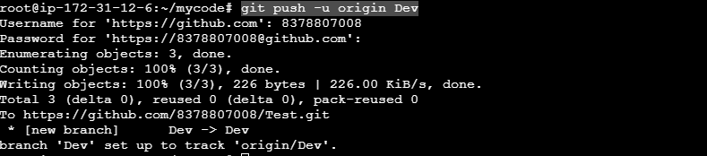

After that u need to enter your username and security token as password

To crate these token Goto Your profile  then Select Setting>devloper Settings>personal Access token select token types  and cck on generate new token

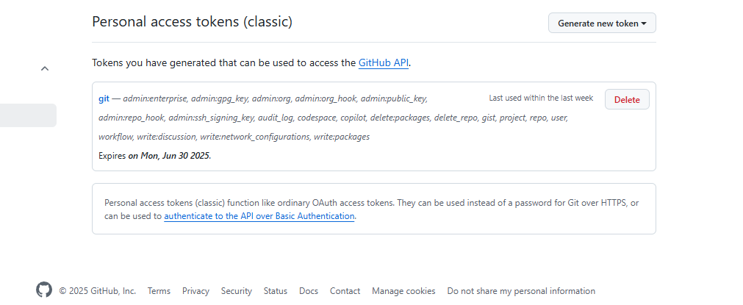

In these way you can create token

9. Dev branch is created to list branches  use git branch it will shows branch list

https://lh7-rt.googleusercontent.com/docsz/AD_4nXccgbKy4trCd4zGFdYTl029oJNenC4CHwVfmJo3lq2_eaGRGfTTptRw77C11dlZyjJ1pp5w5u2i-yH-kVaw3ghVJe24dHnPvC_XiyzmoVFm8AxIW37n_7asIsQAWzQk3XeGAP6s-A?key=or8XTluCLmyXyg8SoRvMNg

10. Tomake new branch Use git branch branch_name

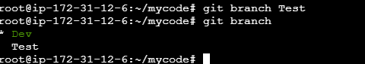

To switch the branch Use git checkout branch_name

https://lh7-rt.googleusercontent.com/docsz/AD_4nXfSPbymGjieGMuNaJQbgVWMiChMCdx0whc2foZolQQ-YWrjEnR3rGnTIlrwqWFImHski5x-2tU_UD2KO2qCoxV8ovjP_6CS87cnXUU8aopVnTevYKXihvTPaD3-DRxnRWNoTthh?key=or8XTluCLmyXyg8SoRvMNg

By switching the directory the code will be automatically copy to another branch

If you do any changes in that then perform following changes

